Gelatine hydrogels, 3% w/V, crosslinked with TGM
Compression test for gelatine gels
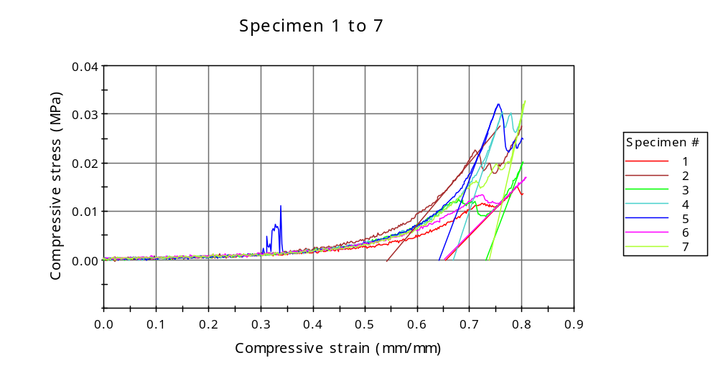
Graph 2
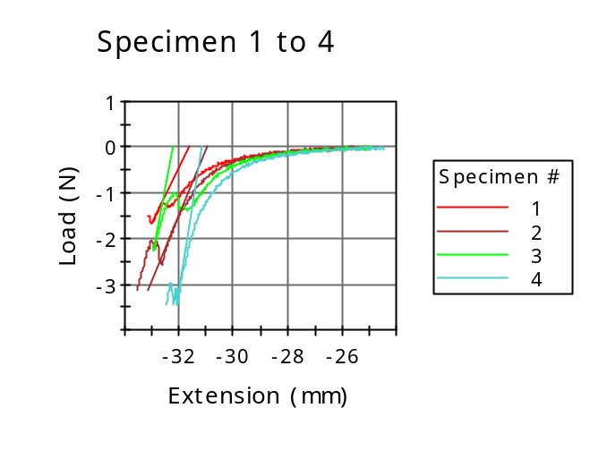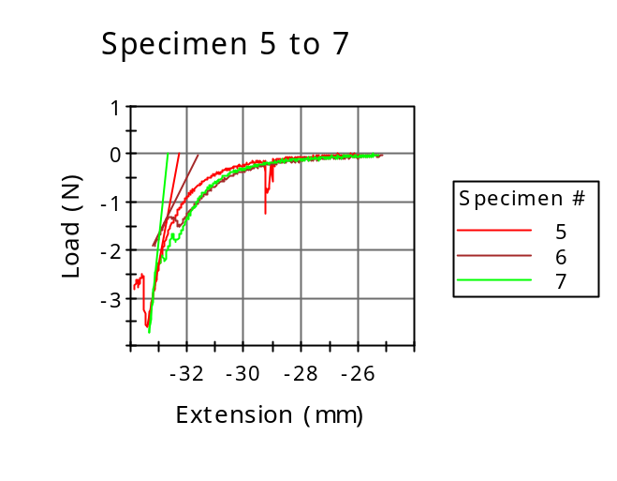

Dimension: Geometry | Circular
Dimension: Diameter | 12.00000 mm
Dimension: Anvil height | 10.00000 mm
Notes: Specimen note 1 | Cylindrical sample compression

 | Diameter  (mm) | Specimen label | Axial Gauge Length (Strain Source)  ()
1 | 12.00000 |  | -10.00000
2 | 12.00000 |  | -10.00000
3 | 12.00000 |  | -10.00000
4 | 12.00000 |  | -10.00000
5 | 12.00000 |  | -10.00000
6 | 12.00000 |  | -10.00000
7 | 12.00000 |  | -10.00000
Mean | 12.00000 |  | -10.00000
Standard Deviation | 0.00000 |  | 0.00000
Coefficient of Variation | 0.00000 |  | 0.00000

 | Anvil height  (mm) | Compressive load at Break (Standard)  (N) | Load at Break (Standard)  (N)
1 | 10.00000 | 1.53724 | -1.53724
2 | 10.00000 | 3.11802 | -3.11802
3 | 10.00000 | 2.28065 | -2.28065
4 | 10.00000 | 3.44631 | -3.44631
5 | 10.00000 | 2.82677 | -2.82677
6 | 10.00000 | 1.92700 | -1.92700
7 | 10.00000 | 3.71872 | -3.71872
Mean | 10.00000 | 2.69353 | -2.69353
Standard Deviation | 0.00000 | 0.80733 | 0.80733
Coefficient of Variation | 0.00000 | 29.97290 | -29.97290

 | Load at Yield (Zero Slope)  (N) | Maximum Slope (Automatic Young's)  (MPa/mm/mm) | Modulus (Automatic)  (MPa)
1 | -1.31523 | 0.10981 | 0.05774
2 | -0.13864 | 0.12813 | 0.00636
3 | -0.08057 | 0.28782 | 0.01069
4 | ----- | 0.32797 | 0.18145
5 | -1.25898 | 0.28270 | 0.19546
6 | -0.16416 | 0.10802 | 0.06168
7 | -0.09551 | 0.48651 | 0.02348
Mean | -0.50885 | 0.24728 | 0.07669
Standard Deviation | 0.60383 | 0.14091 | 0.07937
Coefficient of Variation | -118.66632 | 56.98295 | 103.49194

 | Compressive load at Yield (Zero Slope)  (N) | Extension at Yield (Zero Slope)  (mm) | Compressive strain at Break (Standard)  (mm/mm)
1 | 1.31523 | -32.32613 | 0.80174
2 | 0.13864 | -28.15685 | 0.80003
3 | 0.08057 | -27.34469 | 0.80115
4 | ----- | ----- | 0.80201
5 | 1.25898 | -29.24450 | 0.80236
6 | 0.16416 | -28.73662 | 0.80613
7 | 0.09551 | -27.85322 | 0.80606
Mean | 0.50885 | -28.94367 | 0.80278
Standard Deviation | 0.60383 | 1.78546 | 0.00238
Coefficient of Variation | 118.66632 | -6.16874 | 0.29680

Compressive stress at Break (Standard)
(MPa)
1 | 0.01359
2 | 0.02757
3 | 0.02017
4 | 0.03047
5 | 0.02499
6 | 0.01704
7 | 0.03288
Mean | 0.02382
Standard Deviation | 0.00714
Coefficient of Variation | 29.97290

